**DAILY ONLINE ACTIVITIES SUMMARY**

|  |  |  |  |  |  |  |  |  |
| --- | --- | --- | --- | --- | --- | --- | --- | --- |
| **Date:** | **1-06-2020** | | | | | **Name:** | **Rakesh M Kotian** | |
| **Sem & Sec** | **8 th sec-b** | | | | | **USN:** | **4al16cs072** | |
| **Online Test Summary** | | | | | | | | |
| **Subject** | | **-** | | | | | | |
| **Max. Marks** | | **-** | | **Score** | | |  | |
| **Certification Course Summary** | | | | | | | | |
| **Course** | **Python for machine learning** | | | | | | | |
| **Certificate Provider** | | | **Great learning** | | **Duration** | | | **6 hours** |
| **Coding Challenges** | | | | | | | | |
| **Problem Statement:** | | | | | | | | |
| **Status:solved** | | | | | | | | |
| **Uploaded the report in Github** | | | | | **yes** | | | |
| **If yes Repository name** | | | | | **Rakeshkotian08** | | | |
| **Uploaded the report in slack** | | | | | **yes** | | | |

Online Test Details: (Attach the snapshot and briefly write the report for the same)

Certification Course Details: (Attach the snapshot and briefly write the report for the same)

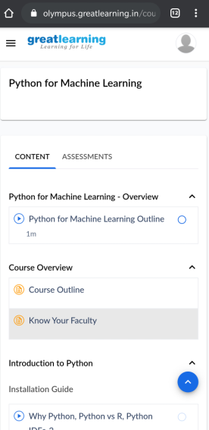

|  |  |
| --- | --- |
| int countnum(int arr[],int key,int size)  {  int count=0;  for(int i=0;i<size;i++)  {  for(int j=i+1;j<size;j++)  {  if(arr[i]+arr[j]<key)  {  count+=1;  }  }  }  return count;  }  int main()  {  int arr[]={1,2,3,4,5,6,7};  int key=7;  int size=sizeof(arr)/sizeof(arr[0]);  int result=countnum(arr,key,size);  cout<<result;  getch();  }   |  | | --- | |  | |